● Create table RealEstate in Hive database, with all the columns present in dataset.

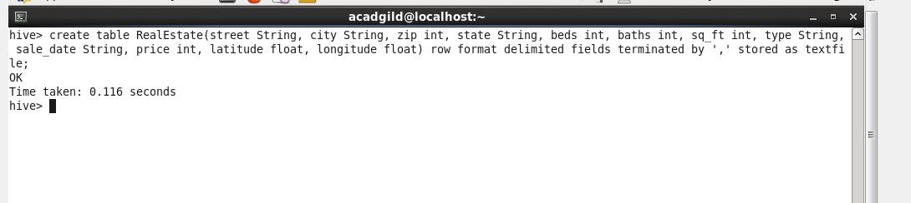

● Load dataset into table realEstate.

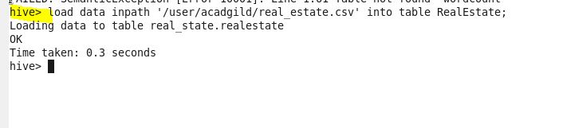

● Using Dynamic partition get separate lists of residential apartments with more than 2 beds and include columns in following order City,Baths,Sq\_feet,Price,flat\_type,Beds respectively.

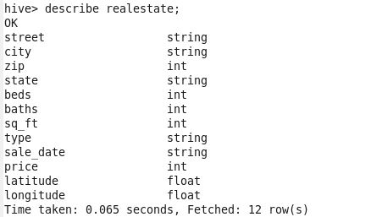

C:\Users\612840.CTS\Desktop\23_3_part_table.JPG

